PART – 2 Machine Learning Question and answers

- Linear regression vs Logistic regression. Model?

Linear Regression | Logistic Regression
Used to predict the continuous dependent variable using a given set of independent variables. | Used to predict the categorical dependent variable using a given set of independent variables.
The outputs produced must be a continuous value, such as price and age. | The outputs produced must be Categorical values such as 0 or 1, Yes or No.
The relationship between the dependent variable and independent variable must be linear. | The relationship DOES NOT need to be linear between the dependent and independent variables.
Used for solving Regression problems. | Used for solving Classification problems.
We are finding and using the line of best fit to help us easily predict outputs. | We are using the S-curve (Sigmoid) to help us classify predicted outputs.
Least square estimation method is used for the estimation of accuracy. | Maximum likelihood estimation method is used for the estimation of accuracy.
There is a possibility of collinearity between the independent variables. | There should not be any collinearity between the independent variable.

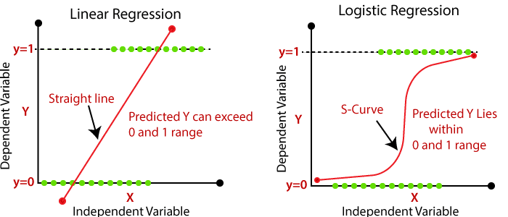
- Importance of batch size while training.
We cant pass a whole dataset in network which increase the load so we divide the dataset into some batches. Example dataset size 60000, batch size is 600 means, iteration to complete 1 epoch = 60000 / 600.
no of iterations = 100

- What is cross entropy?Accuracy vs Loss function.
Cross Entropy : used in logistic regresstion as a cost function to find different between two probabilities(target probabilty, predicted probabilty).

Cross-entropy = Entropy + KL – Divergence
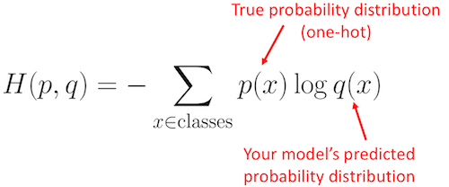
Entropy – focus on important features.

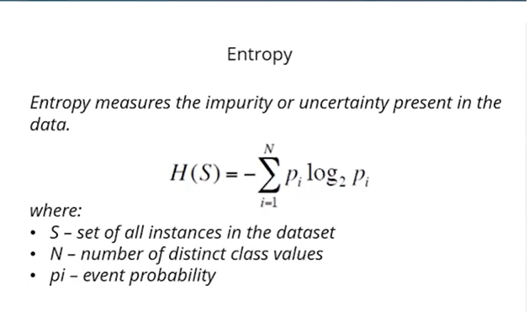

KL Divergence

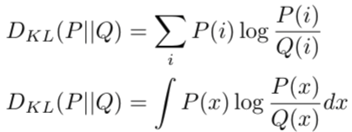

Accuracy Vs Loss:
Both are metric to find the quality of the model. To better the model improve the accuracy and decrease the loss.
Accuracy = Correctly predicted points / total no of points.
loss = actual point – predicted (regression)
loss = actual probabilty – predicted probability (classification)

- Importance of hidden layer. Deep Neural Network.

First of all, hidden layer in artificial neural networks a layer of neurons, whose output is connected to the inputs of other neurons and therefore is not visible as a network output.
Example facial recognition -

Basically, the first hidden layer detects pixels of light and dark, they are not very useful for face recognition, but they are extremely useful to identify edges and simple shapes on the second hidden layer. The third hidden layer knows how to comprise more complex objects from edges and simple shapes. Finally, at the end, the output layer will be able to recognize a human face with some confidence.

- Practical:Train the same model of Part 1 with one hidden layer.Document the performance improvement on using this layer.

Model | Val_accuracy | Val_loss
Logistic Regression | 0.9226 | 0.2672
Neural Network with one hidden layer | 0.9685 | 0.1097

- Training a model?
Model training in machine language is the process of feeding an ML algorithm with data to help identify and learn good values for all attributes involved.

- Necessity of GPU in training. Device parameter?Practical:Compare the training times on a CPU vs. GPU
Importance of GPU in Training:
GPUs are optimized for training artificial intelligence and deep learning models as they can process multiple computations simultaneously.
They have a large number of cores, which allows for better computation of multiple parallel processes. Additionally, computations in deep learning need to handle huge amounts of data — this makes a GPU’s memory bandwidth most suitable.
Torch.device
The torch.device contains a device type ('cpu' or 'cuda') and optional device ordinal for the device type.

 | CPU Enabled | GPU Enabled
Training Time | 34.330979108810425 | 29.341047763824463

Loss functions for Regression problem

https://medium.com/analytics-vidhya/a-comprehensive-guide-to-loss-functions-part-1-regression-ff8b847675d6

MSE
MAE
Mean Absolute Percentage Error
RMSE
Huber loss

Loss functions for Classification problem

https://medium.com/analytics-vidhya/common-loss-functions-in-machine-learning-for-classification-model-931cbf564d42

Binary class loss functions
Binary cross entropy
Hinge loss
Squared Hinge loss

Multi class loss functions
Multiclass cross entropy
KL Divergence loss
Sparse Multiclass cross entropy loss

